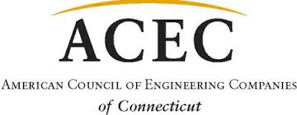

12th ACEC/CT Golf Outing
To benefit the ACEC Political Action Committee
Thursday, July 13, 2023
Keney Park Golf Club
171 Windsor Avenue, Windsor, CT

Help ACEC CT Rise to the Top of the Leader Board in Washington!
Not a Golfer? Not a problem. Come for Dinner. $75.00
▲ Dinner and Awards: 3:00pm ▲.
(**Personal Check or Personal Credit Card Only**)

Name and Firm:
Address:
City: State: Zip:
Phone: Email:
Amount: $ Payment by Check MasterCard, VISA, Amex
Account Number: Exp. Date: 3 digit CVV Code:
Cardholder’s Name: Signature:
Address: City: State: Zip:
Please Mail or Email your registration and make check payable to ACEC/PAC:
ACEC CT, P.O. Box 627, North Haven, CT, 06473 ▲ email tricia@grassrootsct.com or lisa@grassrootsct.com
Sponsorships Available... See Sponsor Form

