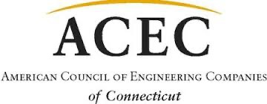

12th ACEC/CT Golf Outing
To benefit the ACEC Political Action Committee
Thursday, July 13, 2023
Keney Park Golf Club
171 Windsor Avenue, Windsor, CT
Help ACEC CT Rise to the Top of the Leader Board in Washington!
Enjoy a great round of golf and network with friends at our ninth annual golf outing!
Includes 18 holes of golf, use of driving range, putting and chipping practice,
cart, breakfast bag, boxed lunch and dinner. Up to 5 Mulligans will be available for purchase at Registration.
Phased Registration Starting at 8:30am ▲ Shot Gun Start: 10:30am ▲ Dinner and Awards: 3:00pm
$175 per person if you register by June 14th ▲ $200 per person after June 14th
**Personal checks/personal credit cards only!**

Names:

Firm:
Address:
City: State: Zip:
Phone: Email:
Amount: $ Payment by ___Personal Check ___Personal MasterCard, VISA, Amex
Account Number: Exp. Date: 3 digit CVV Code:
Cardholder’s Name: Signature:
Address: City: State: Zip:
Please Mail or Email your registration and make check payable to ACEC/PAC:
ACEC CT, P.O. Box 627, North Haven, CT, 06473 ▲ email tricia@grassrootsct.com or lisa@grassrootsct.com

