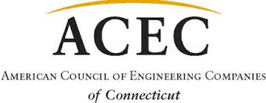
12th ACEC/CT Golf Outing
To benefit the ACEC Political Action Committee
Thursday, July 13, 2023
Keney Park Golf Club

Help ACEC CT Rise to the Top of the Leader Board in Washington!
Sponsorships
Platinum Sponsor - $1200
(Includes Hole Sponsorship)
Gold Sponsor - $900
(Includes Hole Sponsorship)
Silver Sponsor - $700
(Includes Hole Sponsorship)
Bronze Sponsor - $300
Raffle Prize Sponsors will be recognized in program and announcements.
Corporate Checks or Credit Cards are acceptable for sponsorships. Other Sponsorships also available.

Firm:
Contact:
Address:
City: State: Zip:
Phone: Email:
Amount: $ Payment by Company Check MasterCard, VISA, Amex
Account Number: Exp. Date: 3 digit CVV Code:
Cardholder’s Name: Signature:
Address: City: State: Zip:
Please Mail or Email your registration and make check payable to ACEC-CT:
ACEC CT, P.O. Box 627, North Haven, CT, 06473 ▲ email tricia@grassrootsct.com or lisa@grassrootsct.com

